Amazon Q
Installation and integration in IDE
THE PASSIONATE BUDDIES 🎯🤝

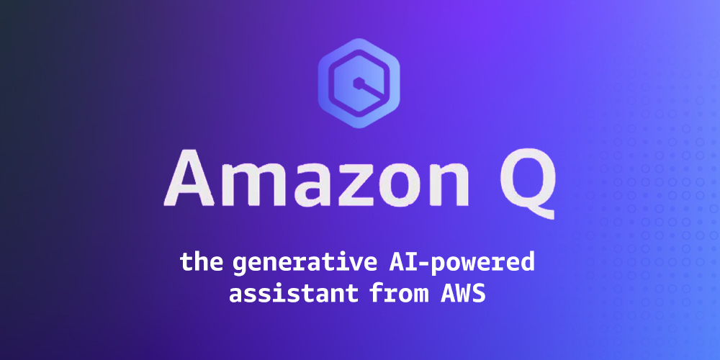

Content:
- Amazon Q Introduction
- Amazon Q Plugin Installation
- Amazon Q Integration And Use (For Developers)

2026
Amazon Q Introduction

What is Amazon Q?

Amazon Q Developer is a generative artificial intelligence (AI) powered conversational assistant that can help you understand, build, extend, and operate AWS applications. You can ask questions about AWS architecture, your AWS resources, best practices, documentation, support, and more. Amazon Q is constantly updating its capabilities so your questions get the most contextually relevant and actionable answers. The most capable generative AI-powered assistant for building, operating, and transforming software, with advanced capabilities for managing data and AI. Amazon Q can now help you write, modify, and maintain code by combining the power of natural language understanding with the ability to take actions on your behalf such as directly making code changes, modifying files, and running commands.

Agentic coding experience
Amazon Q Developer uses information across native and MCP server-based tools to intelligently perform actions beyond code suggestions, such as reading files, generating code diffs, and running commands based on your natural language instruction. Simply type your prompt in your preferred language and Q Developer will provide continuous status updates and iteratively apply changes based on your feedback, helping you accomplish tasks faster.

Use case:
- Implement new features –
Generate new code across your entire project and implement features.

- Generate documentation –
Write API, technical design, and onboarding documentation.

- Automate code reviews –
Perform code reviews, flagging suspicious code patterns and assessing deployment risk.

- Generate unit tests –
Generate unit tests and add them to your project, helping you improve code quality, fast.

- Transform workloads –
/transform to upgrade your Java applications in minutes, not weeks.

Core features:

- MCP support –
Add Model Context Protocol (MCP) servers to give Amazon Q Developer access to important context.

- Inline suggestions –
Receive real-time code suggestions ranging from snippets to full functions based on your comments and existing code.
15+ languages supported including Python, TypeScript, Rust, Terraform, AWS Cloud formation, and more

- Inline chat –
Seamlessly initial chat within the inline coding experience. Select a section of code that you need assistance with and initiate chat within the editor to request actions such as "Optimize this code", "Add comments", or "Write tests".

- Chat –
Generate code, explain code, and get answers about software development.

- Code reference log –
Attribute code from Amazon Q that is similar to training data. When code suggestions similar to training data are accepted, they will be added to the code reference log.

Amazon Q Plugin Installation in IDE

IntelliJ IDEA

[Step 1]: Open IntelliJ IDEA >> Click on Settings Icon (Top Right Corner) >> Click on Plugins

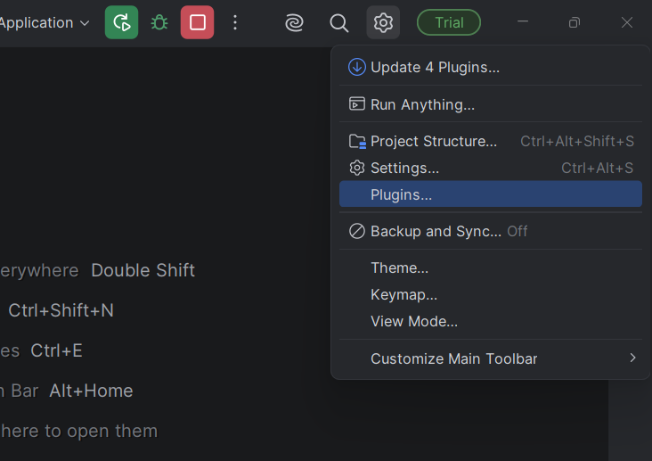

[Step 2]: In Search bar, type – Amazon Q >> Click on Install

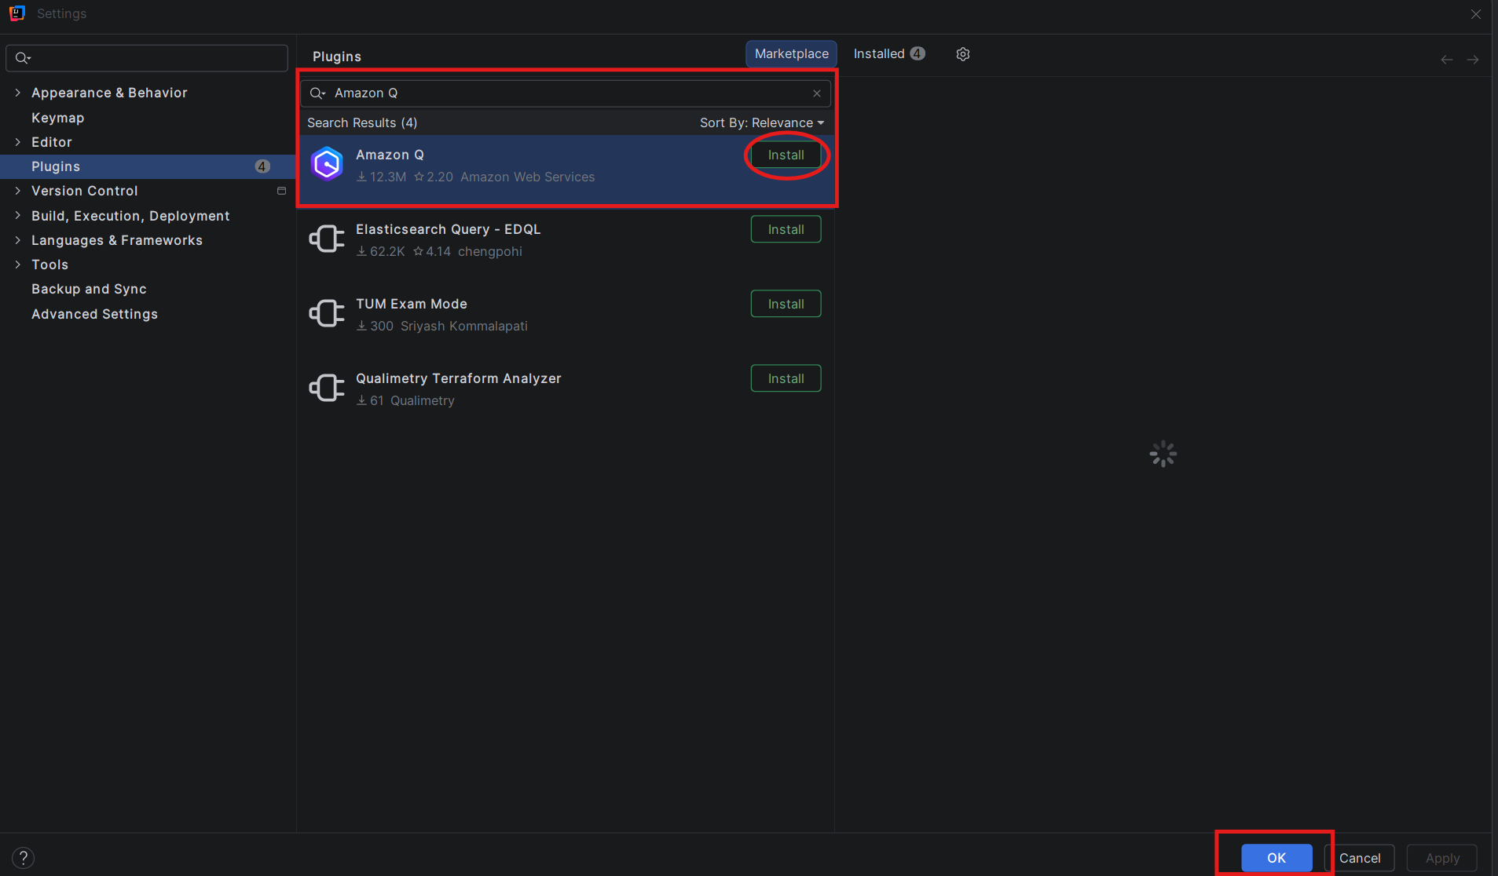

[Step 3]: Click on Accept. It will start the installation.

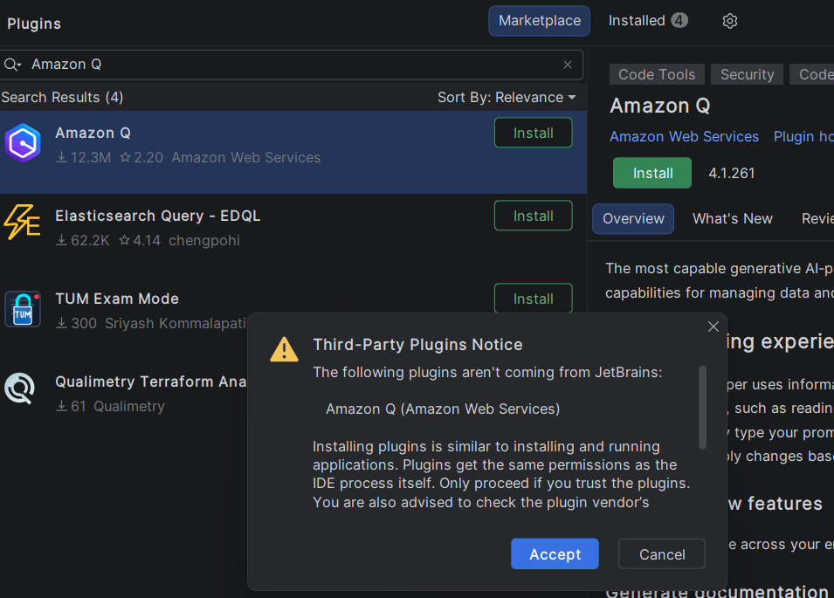
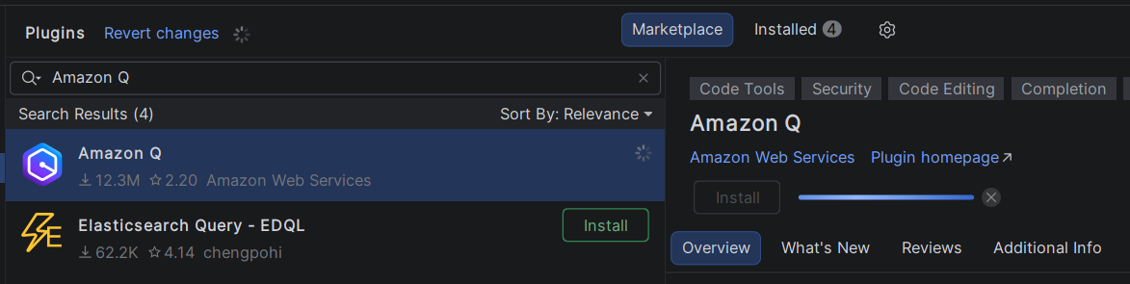

[Step 4]: Click on Apply and OK >> Restart. We need to restart the IDE to reflect the plugin changes.
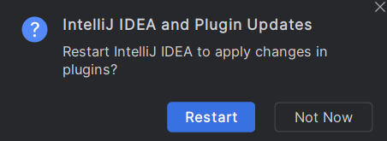

Once IDE is restarted – we can see below “Amazon Q Chat” option in IDE.

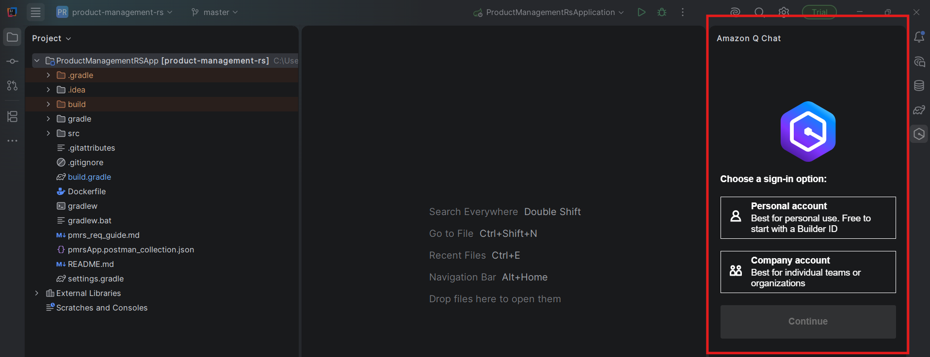

[Step 5]: To work with Amazon Q – we must need to login first. Click on Personal account for personal use. It will open a browser window where we need to provide email, person name details. Once that is provided, AWS will send verification code on provided mail which needs to be provided in same window. If you see any popup for access (like – Kiro) then provide it.

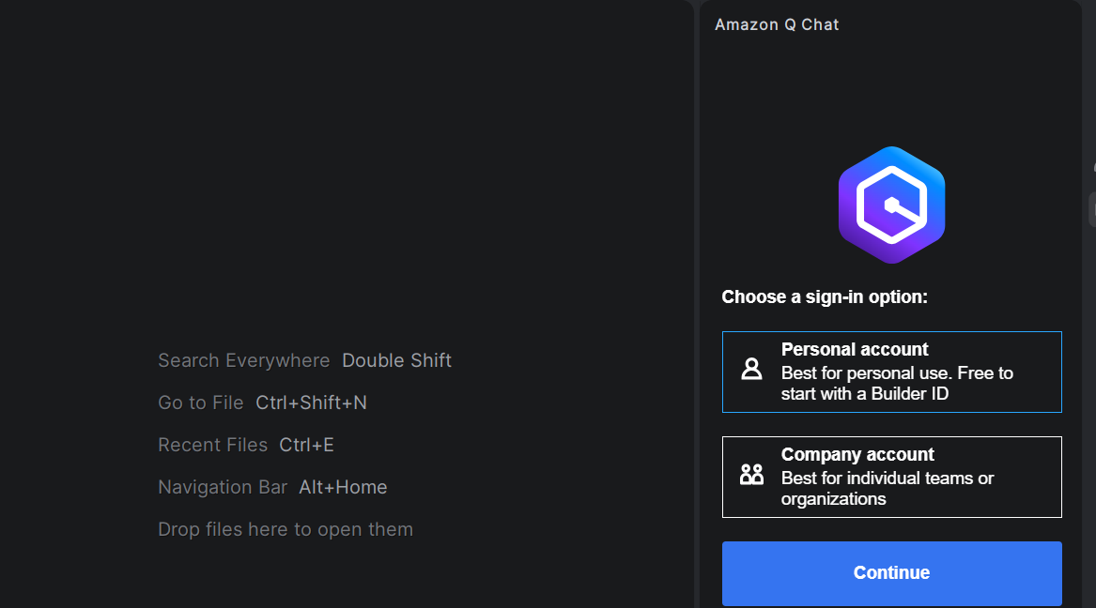
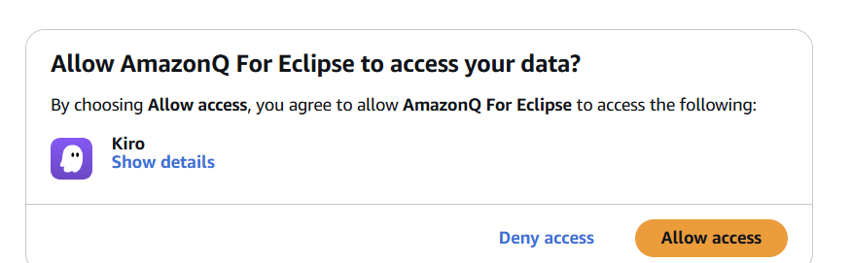
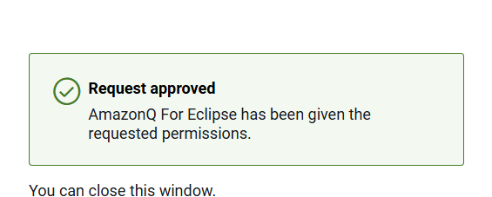

[Step 6]: Once verification is complete, close the browser window and return to the IDE. You will see that the Amazon Q login has been successfully completed, and you can proceed to use it by providing prompts or questions.

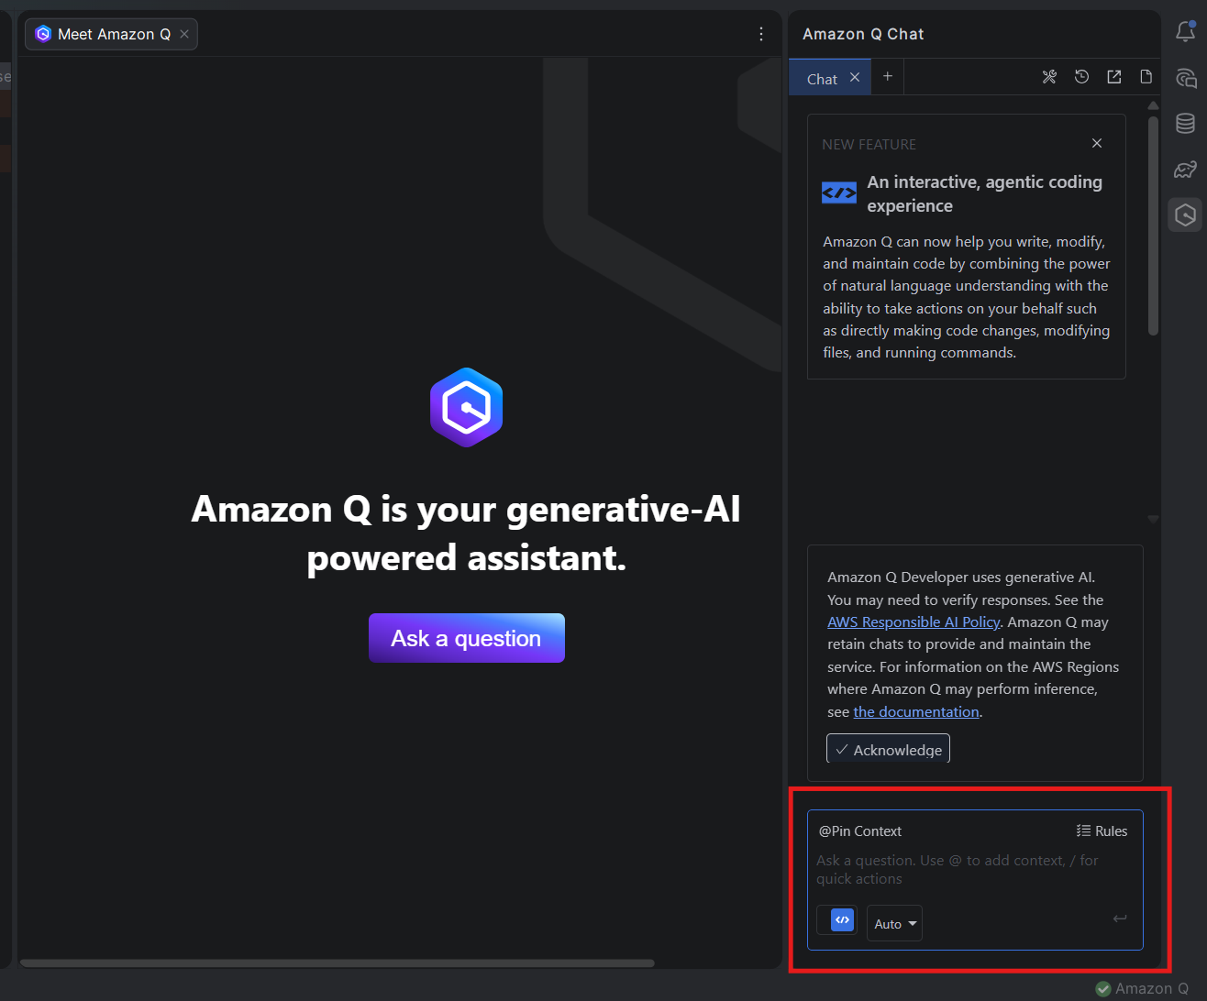

Eclipse / Spring Tool Suite

[Step 1]: Open Eclipse or STS >> Help >> Eclipse Marketplace >> Find >> Type – “Amazon Q” >> Install >> Accept Terms >> Finish

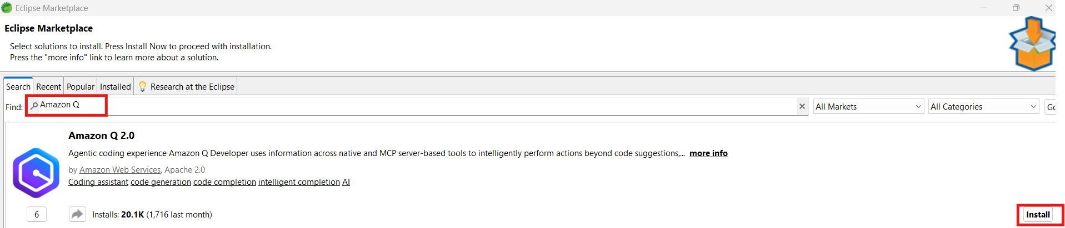

[Step 2]: Trust Authorities >> Restart Now

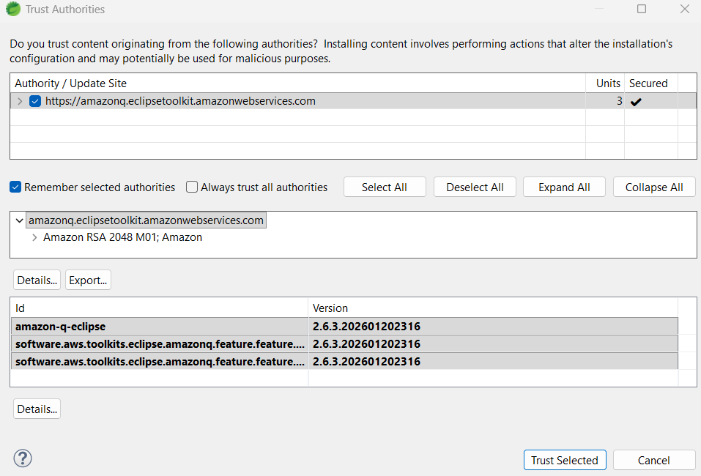

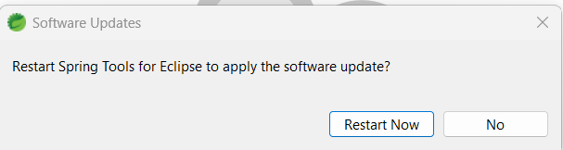

Once IDE is restarted – we can see below “Amazon Q Chat” option in IDE.

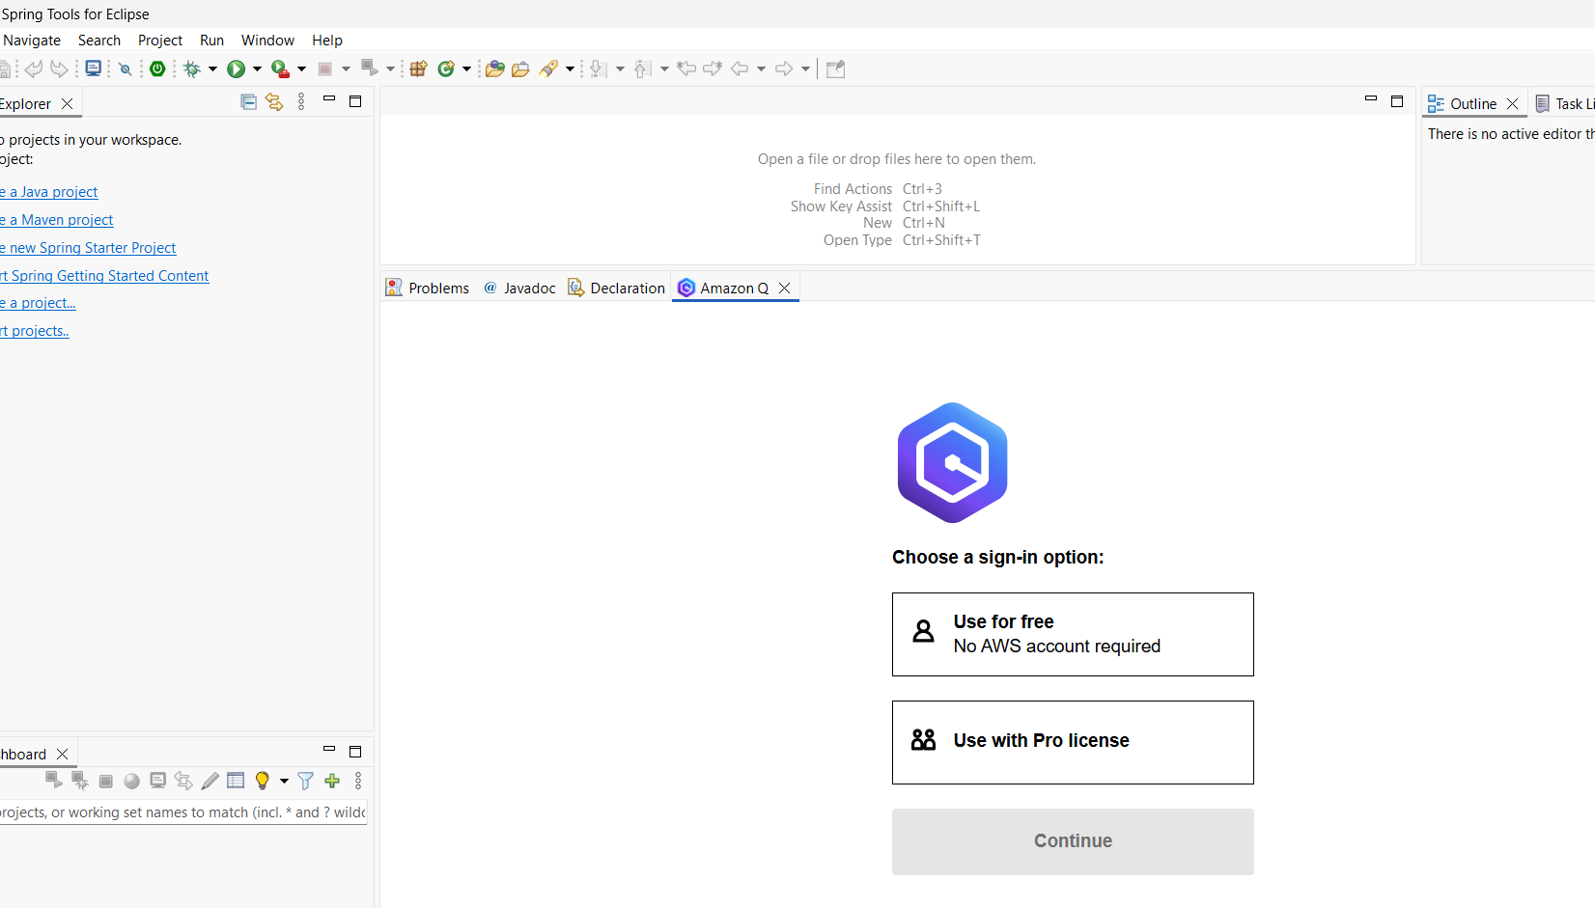

[Step 3]: To work with Amazon Q – we must need to login first. Click on Personal account for personal use. It will open a browser window where we need to provide email, person name details. Once that is provided, AWS will send verification code on provided mail which needs to be provided in same window. If you see any popup for access (like – Kiro) then provide it. Once verification is complete, close the browser window and return to the IDE. You will see that the Amazon Q login has been successfully completed, and you can proceed to use it by providing prompts or questions.

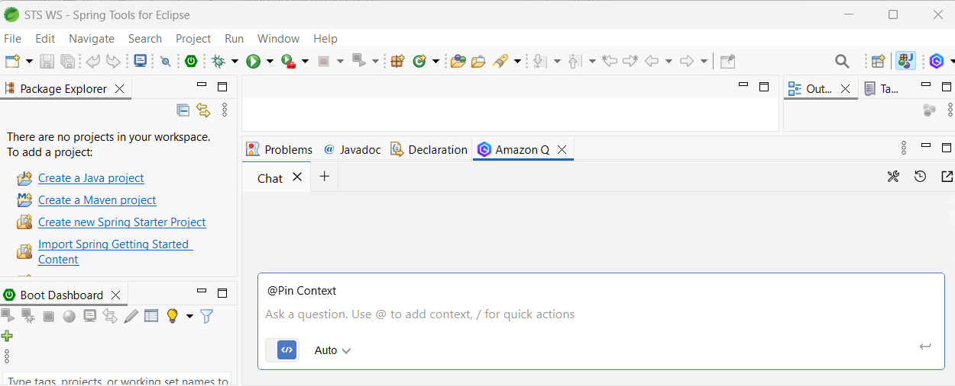

Amazon Q Integration And Use (For Developers)

- How to check git status?

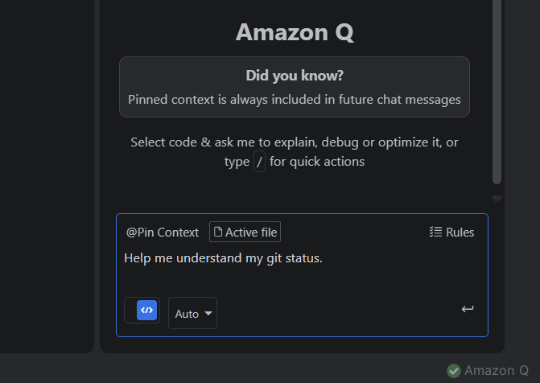

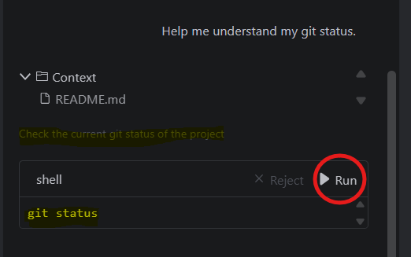

Click on run button to check the status.

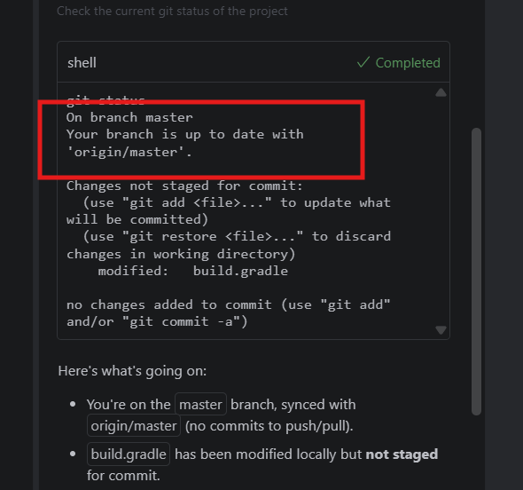4

- Analyze project and suggest if any changes need to be done.

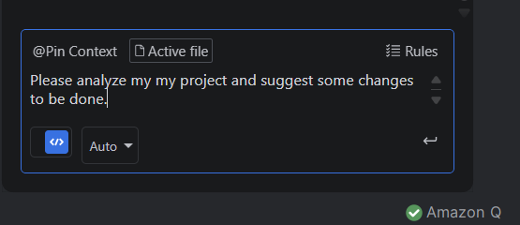

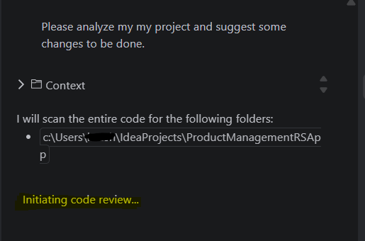
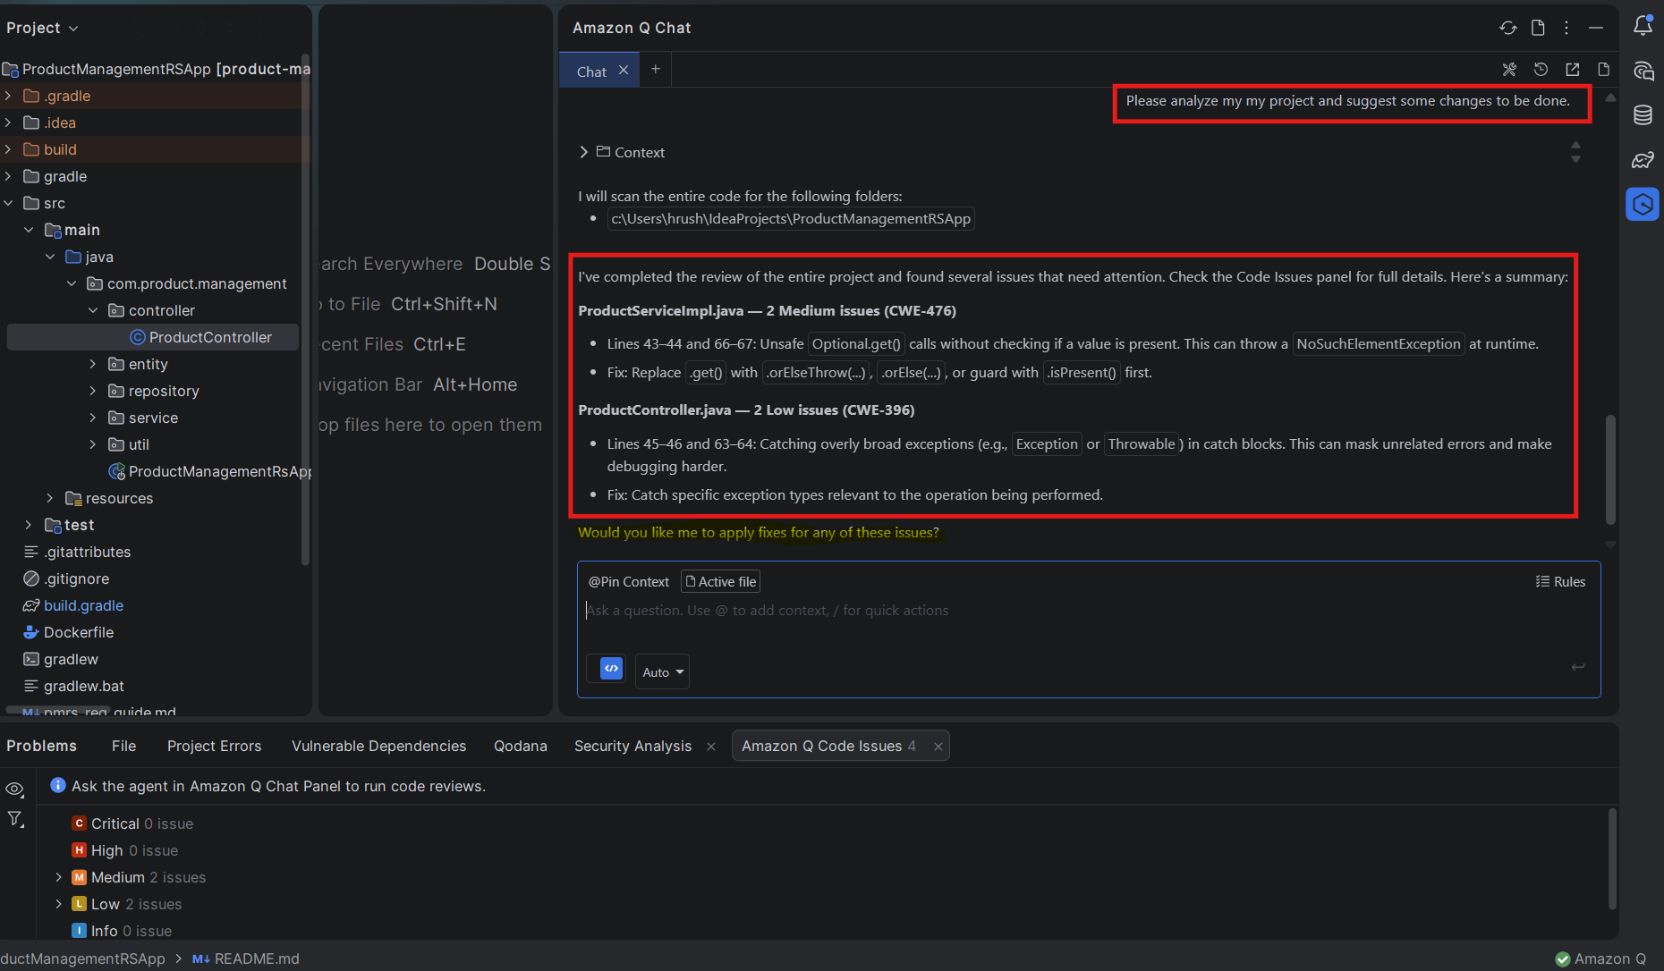

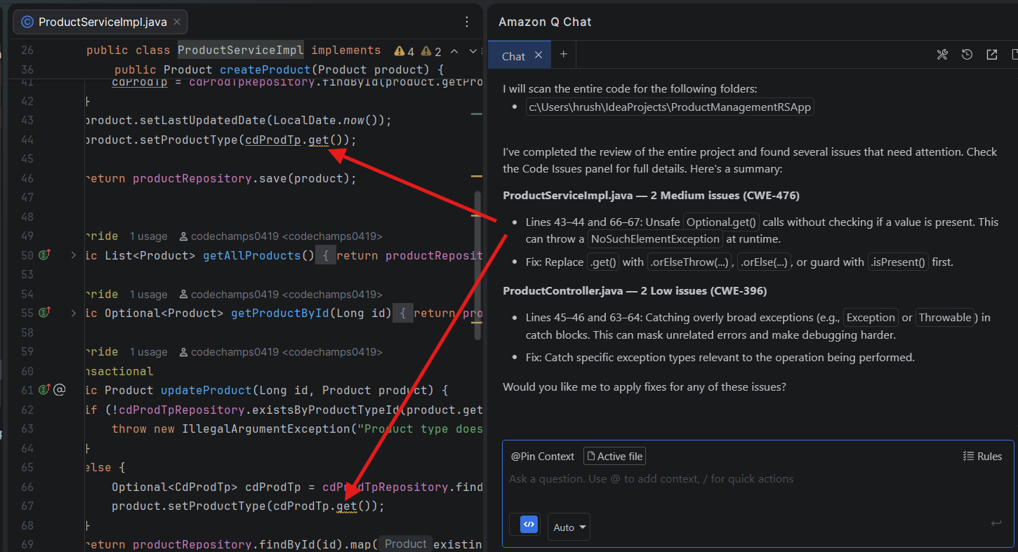

- Apply fixes for all medium level issues. (Skip low level issue for now)

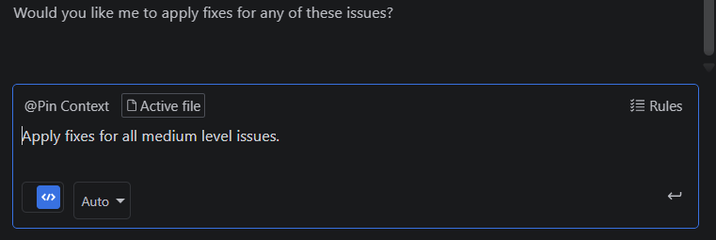

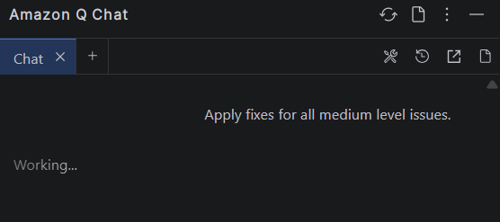

Amazon Q will make changes in file and fix this issue.

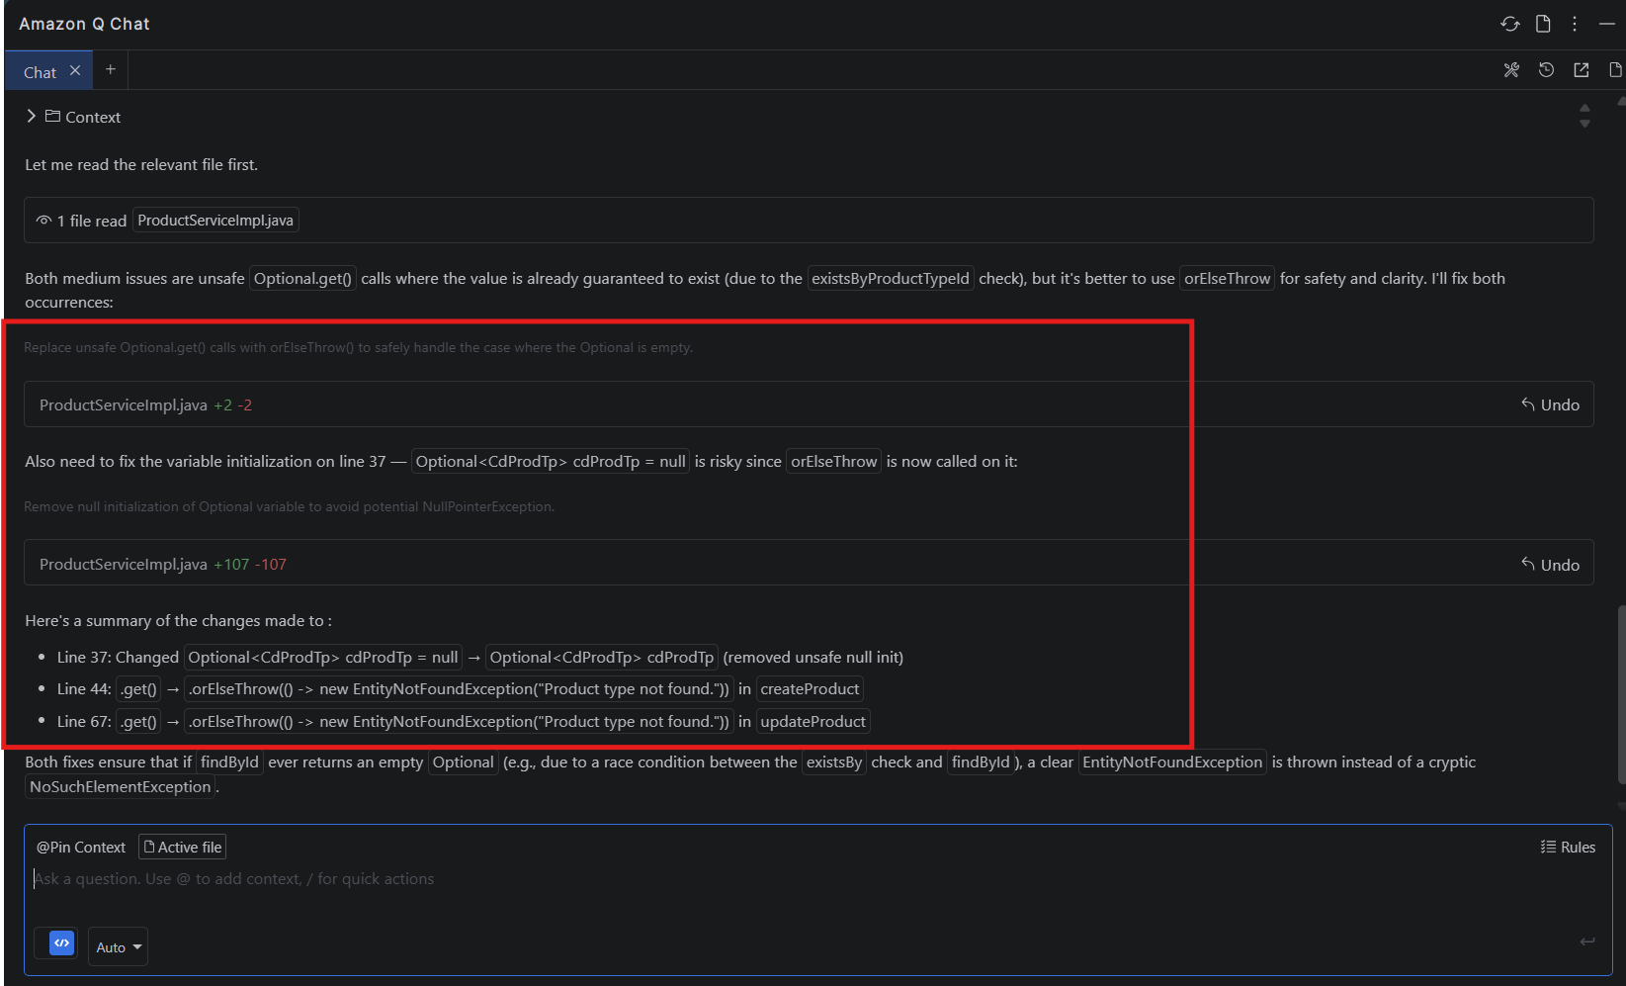

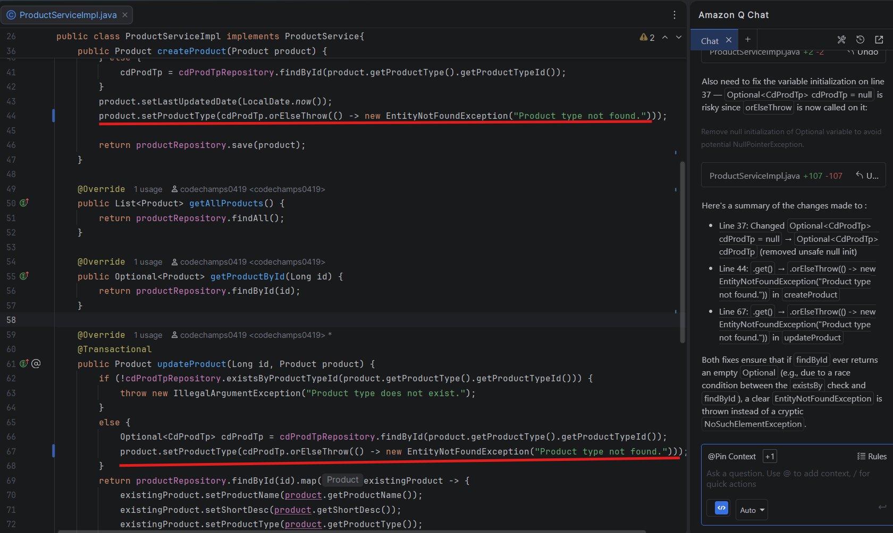

Once the changes are completed and the issues are resolved, we will review the code again to verify whether the concerns raised in the earlier code review have been properly addressed. (We can see no medium level issue are reported)

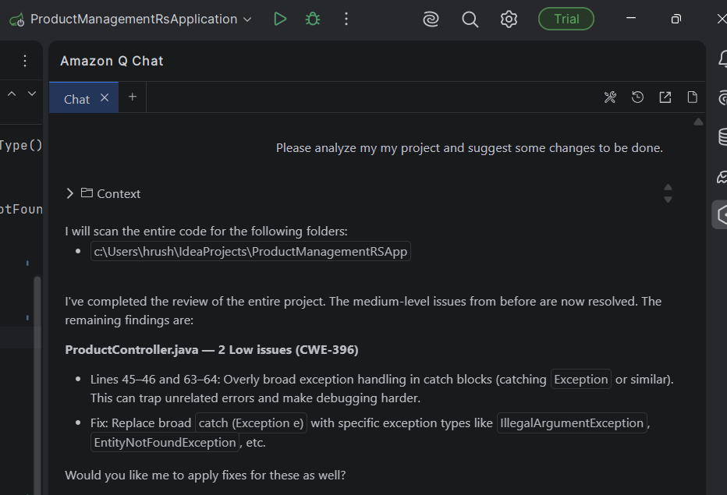

- Generate Unit Tests for Application:

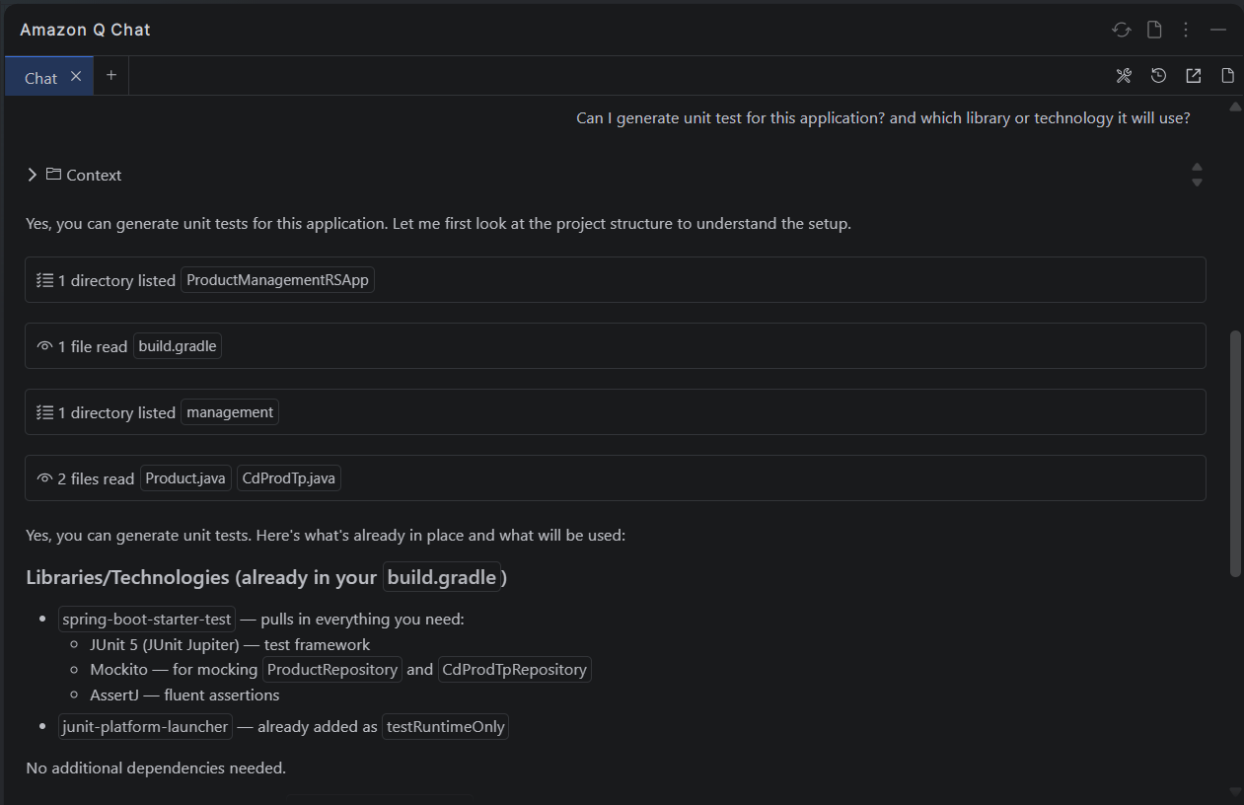

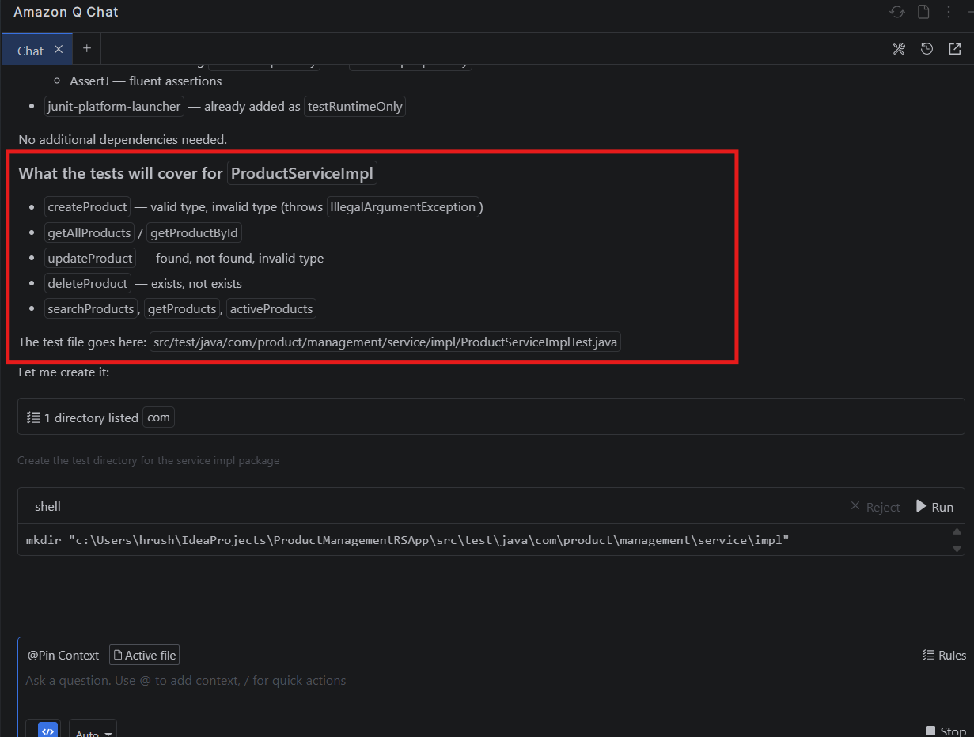

Currently, there are no any unit test files are created or generated. So, let’s give prompt to generate the unit tests for application.

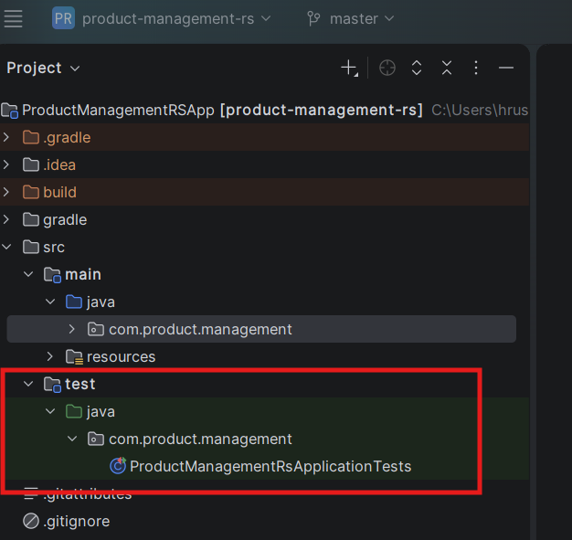

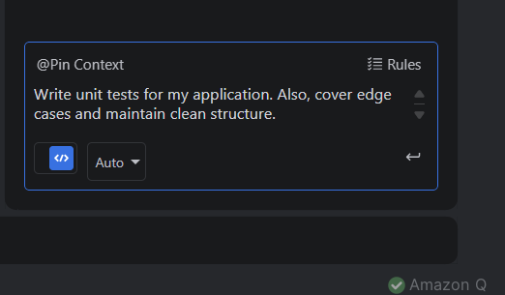

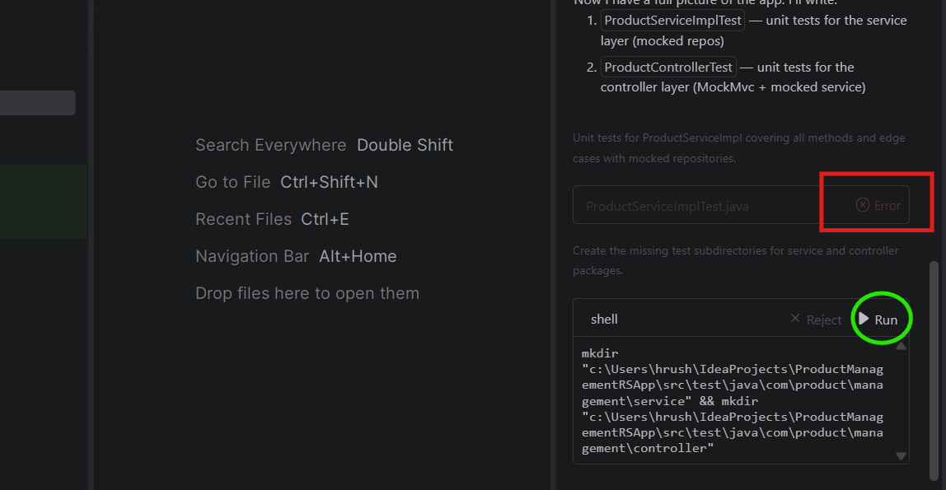

At times, the file creation may fail and prompt you to run a command. In such cases, manual intervention is required. Since this works like an interactive chat, you may need to respond and perform the suggested actions accordingly. It has provided Run option to generate the file or directory. We just need to click on “Run”.

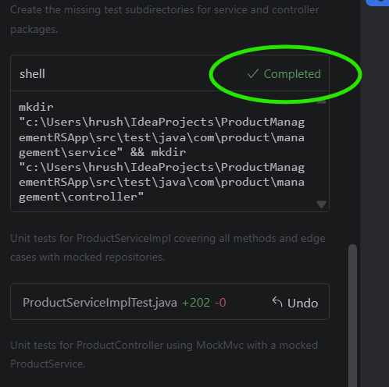

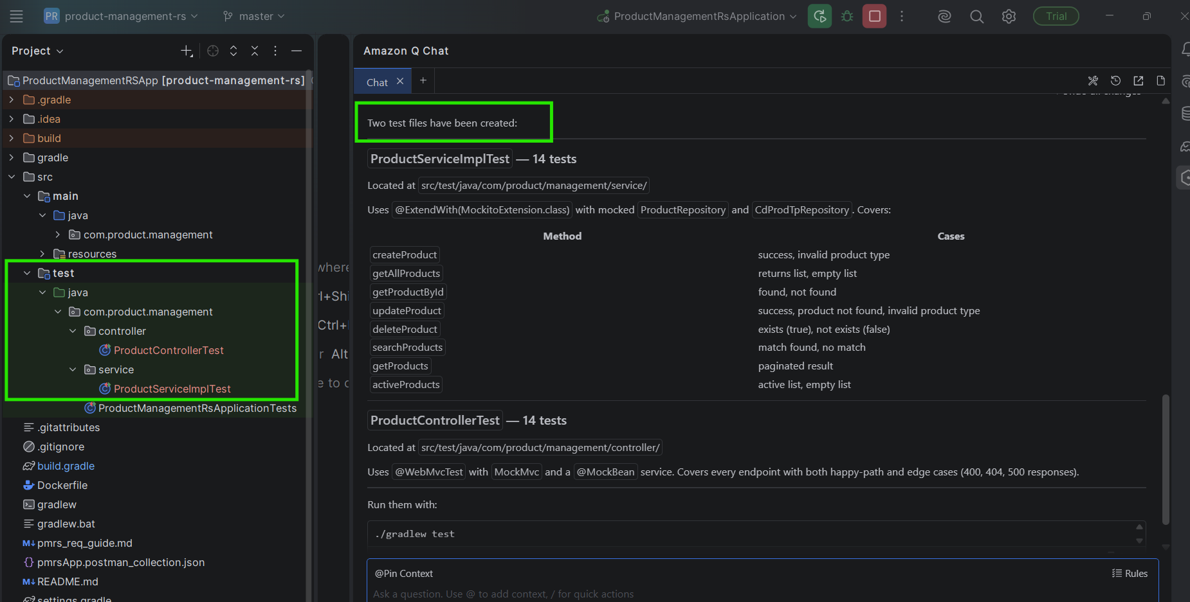

The unit tests have been successfully generated. You can now proceed to run them and verify the results. To run the tests for application – right click on project >> Run “Tests”

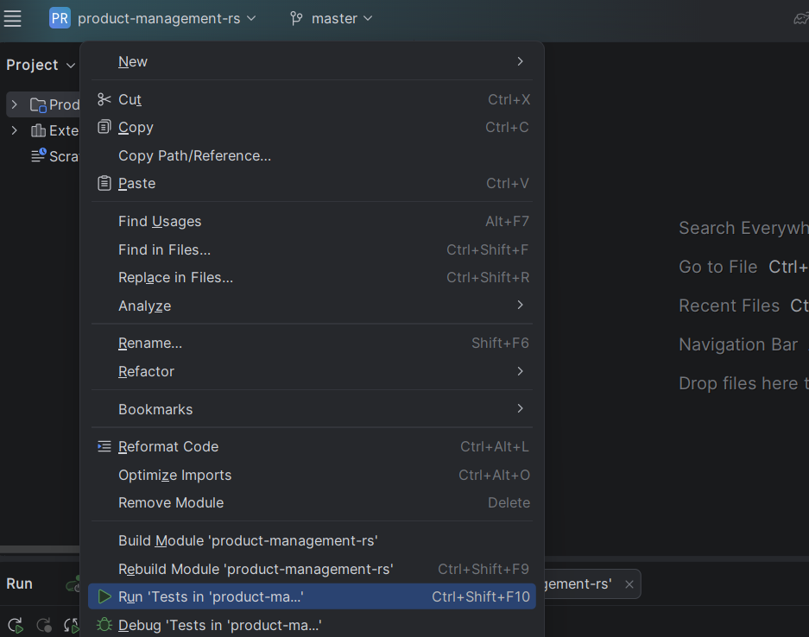

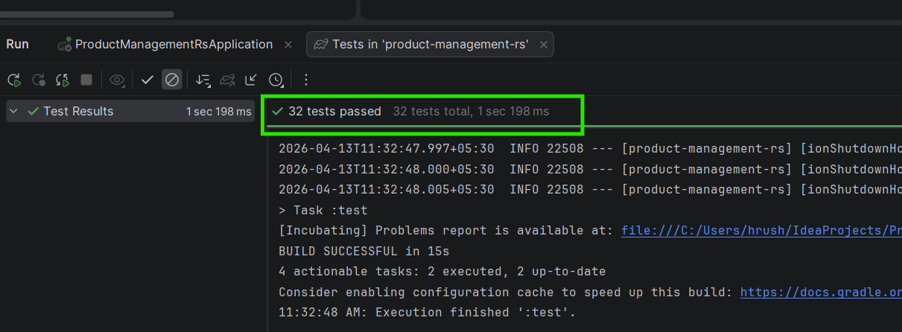

To view the test report, open the index.html file located in the build/reports/tests/test/ directory. Open the file and Hover over the content in file to see the browser option in the same window, then click it to open the report in your browser. Alternatively, you can navigate to the same file path in File Explorer and open the index.html file directly.

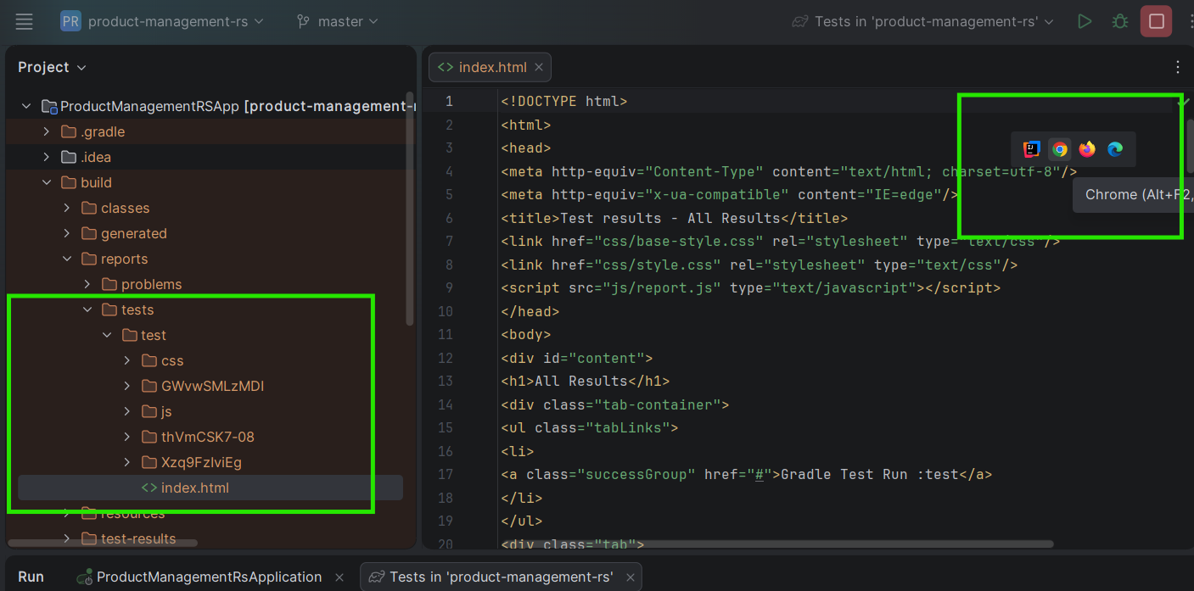

Test Report –

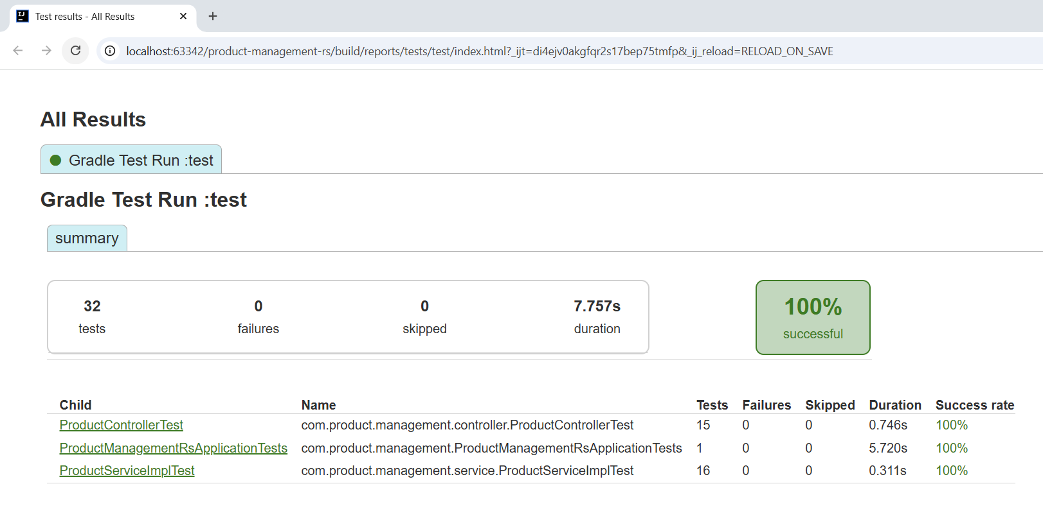

If we want to see code coverage, add this to build.gradle file and build the project.
plugins {
id 'jacoco'
}

jacocoTestReport {
dependsOn test
}

To run the test with coverage, open build.gradle file. Go to the jacocoTestReport option and click on run button. It will show some option to run the test. We need to click on run tests with coverage option.

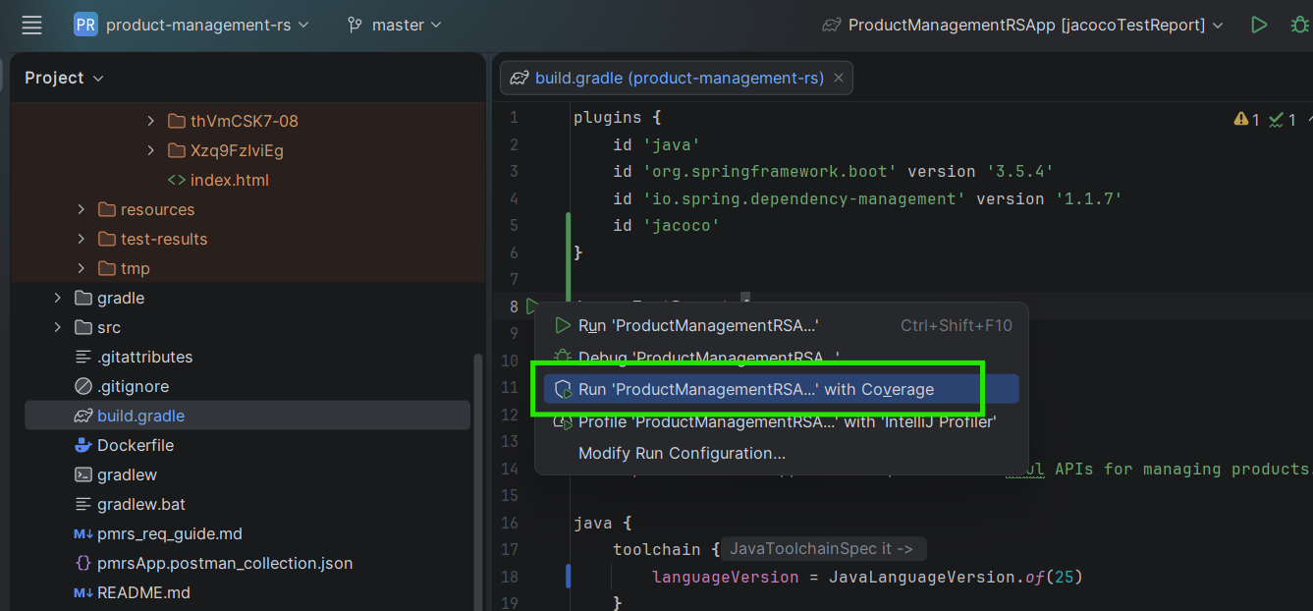

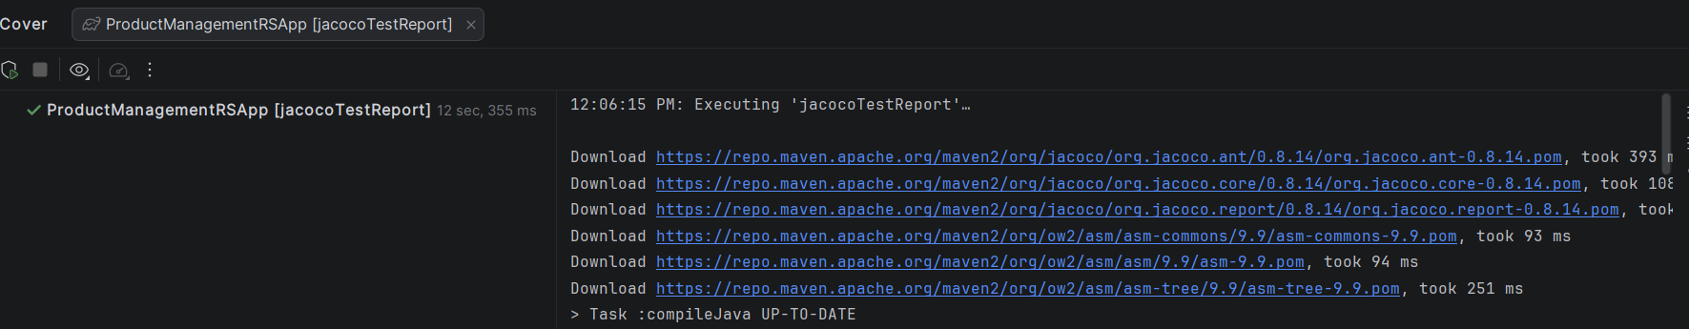

To view the test report, open the index.html file located in the build/reports/jacoco/test/html/ directory. Open the file and Hover over the content in file to see the browser option in the same window, then click it to open the report in your browser. Alternatively, you can navigate to the same file path in File Explorer and open the index.html file directly.

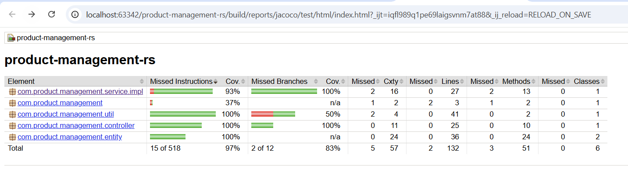

Amazon Q can assist with a variety of development tasks - here are some practical use cases and example prompts. It can significantly improve development productivity when used with clear prompts and iterative follow-up interactions.
~ Codebase Understanding (Huge Time Saver):
Prompt - Explain this project structure and data flow

~ Root Cause Analysis (Debugging):
Prompt - Why is this error happening? Suggest fix.
Prompt - Fix this Null Pointer Exception and explain the cause.
(You can paste: Stack trace, Logs, Code snippet)

~ Refactoring Suggestion:
Prompt - Improve this code for readability, performance, and testability

~ Test Generation + Coverage Gaps:
Prompt - Generate unit tests and identify missing test cases

~ Documentation Generation:
Prompt - Generate API documentation for this controller

~ Security Review:
Prompt - Check this code for security vulnerabilities

~ Migration & Upgrade Help:
Prompt - Convert this code from Java 8 to Java 17

~ Optimization:
Prompt - Optimize below JPA Query: query
Prompt - Optimize this method for better performance.

~ What’s Wrong with This Design?
Prompt - Review this design and suggest improvements.

~ Smart Follow-ups:
Prompt - Improve the given solution. Explain why this approach is better than existing.

